

Sample comms
The Joyous sample comms resource is designed to make it easy for your internal communications team to raise awareness of upcoming Joyous campaigns and their associated outcomes.

Table of Contents
Email Comms Error! Bookmark not defined.
1. Introducing Joyous to all employees 3
2. Invitation to responder training 4
3. Launching a Joyous campaign 5
4. Closing the campaign feedback loop 6
5. Socialize campaign actions taken 7
Talk tracks Error! Bookmark not defined.
1. Raise awareness of upcoming campaign 9
2. Encouragement during the campaign 10
3. Closing the loop & actions taken 11
Appendix Error! Bookmark not defined.
1. What is Joyous video Error! Bookmark not defined.
2. Joyous text message example 13
3. Joyous email example 14
4. Joyous chat apps example 15

Email Comms
For team members who have regular access to email, you can use the following sample email communications to raise awareness of Joyous, upcoming campaigns, and resulting actions.

Sample Comms
The Joyous sample comms resource is designed to make it easy for your internal communications team to raise awareness of upcoming Joyous campaigns and their associated outcomes.

1. Introducing Joyous to all employees
Subject: Introducing Joyous, helping us turn your ideas into action
To: All employees
Send: 1-2 weeks before launching Joyous

Dear Team,
We believe that the best ideas come from those who are closest to the action—you, our frontline team. That's why we're excited to invite you to participate in a new pilot program using a tool called Joyous, designed to put your insights at the heart of our decision-making process.

Over the coming weeks, you'll receive a few SMS messages from Joyous, asking for your input on an important topic that our senior leaders are considering. It is only going to ask you two quick questions, and should only take a minute of your time. Your feedback will directly influence the actions we take, and this is your chance to help shape the future of our business.

This is more than just a pilot—it's an opportunity to show the power of your ideas and prove the impact you can make. If this tool is successful, it will become a key way for us to regularly gather input from the frontline as we make changes and improvements. Your participation means you'll be helping lead change, rather than just having it happen around you.

We’re counting on your honest and thoughtful input to make this pilot a success. Your voice matters, and this is your opportunity to make it heard.
Thank you for your commitment and for being an essential part of our team.

Best regards,
[Name]
[Position]

2. Invitation to responder training
Subject: Invitation to responder training
To: Campaign responders
Send: 1-2 weeks prior to responder training session

[Greeting]

You have been selected to be one of the responders in the upcoming Joyous campaign about [campaign objective].

Why were you selected?
You were selected because you have a deep understanding of the [campaign objective/challenge] and are well positioned to answer questions, continue conversations, and action relevant feedback.

What this involves?
[The target audience] will receive a two-part question via [contact method] once a week for [3] weeks. As a responder, you will be able to see the feedback provided by the target audience and reply to individuals.

What’s next?
We want to make sure you are well equipped to navigate and respond in the Joyous platform. On [Date], a Joyous team member will run a short training session on how to get the most out of the tool and share tips on how to respond effectively.

You will receive a calendar invitation shortly.

Regards

[Senior leader]

3. Launching a Joyous campaign
Subject: Help us [campaign objective]
To: Target audience
Send: One week before first campaign question is sent

[Greeting]

You have been selected to participate in the upcoming Joyous campaign. The campaign will start on [Date].

Your feedback is critical for [campaign objective]. We want to use your feedback to make improvements that are meaningful to you. [Any other campaign context].

Things to know:
Our goal is to build a culture based on trust, transparency, and open feedback.
- Feedback is open, not anonymous. We want to encourage you to share your honest and constructive feedback openly. Your responses to questions will be visible to [Responder group] who will be able to have a conversation with you directly in Joyous.

- Quick, regular chats. It’s quick and easy to give feedback! You’ll receive 1 question set per week, for 3 weeks. Questions take two minutes or less to respond to.

- Rating Scale. The Joyous rating scale questions measure agreement with a statement using an 11- point scale from 0 (Strongly disagree) to 10 (Strongly agree).

Our team is here to answer any questions you might have at any stage.

Regards,

[Campaign lead]

4. Closing the campaign feedback loop
Subject: Thank you for sharing your ideas in Joyous!
To: Target audience + responders
Send: After top actionable themes have been identified

[Greeting]

The Joyous campaign on [campaign objective] has now closed. We want to thank everyone who took the time to provide feedback. Your ideas will influence the changes we make.

Below are some of the high-level actionable insights we surfaced from your feedback:

- [Theme 1]
- [Theme 2]
- [Theme 3]

What happens next?
Our team will build an action plan based on the campaign insights and we will inform you of any changes we make.

Regards,

[Campaign lead]

5. Socialize campaign actions taken
Subject: Changes made because of your Joyous feedback
To: Target audience + responders
Send: After actions have been taken

[Greeting]

In [Campaign month, year], we ran a Joyous campaign to help [campaign objective]. We have now taken action based off the insights gained from the campaign.

Below are some of the changes we implemented as a result:

- [Change 1]
- [Change 2]
- [Change 3]

We would like to thank everyone who took the time to share their ideas and expertise. Because of your feedback, we were able to make a significant impact to [campaign objective].

Regards,

[Campaign lead]

Talk tracks
In some cases, where email Is not the best options to communicate to staff (e.g. field workforces), you can use these talk tracks to help support managers to easily explain Joyous and create awareness of upcoming campaigns in their regular team or 1-1 meetings.

1. Raise awareness of upcoming campaign
Introduction
“Joyous is a new tool that [organization] will be using to gather your ideas and leverage your expertise in order to solve critical businesses challenges and ultimately make life better for you at work. [Organization] recognises that our employees are best positioned to provide insight into our biggest challenges”.
How does it work?
Joyous is run in campaign cycles. Each campaign is usually three weeks long, with a two-part question each week focusing on a specific business challenge.
Your responses will be visible to a select group of [organization] leaders who will be able to have a conversation with you directly in Joyous. Your ideas will then influence the improvements [organization] makes.
What to expect?
You have been selected to participate in the next campaign. Your ideas and expertise are needed to help [campaign objective].

Starting on [date], you will receive a two-part question via [contact method] once a week for [3] weeks. Answering each week's questions will take 2 minutes or less.

Your responses to questions will be visible to [Responder group] who will be able to have a conversation with you directly in Joyous.

Resources
Joyous FAQ page: https://help.joyoushq.com/faqs
Joyous support email: support@joyoushq.com
Campaign lead email:

2. Encouragement during the campaign
Introduction
As you may be aware, we are currently running a campaign on [campaign objective]. We have seen some great ideas coming from the team members so far.
This is just a reminder to take the two minutes to provide your valuable feedback on [campaign objective].

What are the benefits of participating?
- Your ideas will influence the changes [Organization] make.
- You will be able to have a direct conversation with someone that can make the change.
- You have the chance to [make things easier and make life better at work].

Resources
Joyous FAQ page: https://help.joyoushq.com/faqs
Joyous support email: support@joyoushq.com
Campaign lead email:

3. Closing the loop & actions taken
Context
In [Campaign month, year], we ran a Joyous campaign to help [campaign objective].
Thank you to everyone who took the time to share their ideas and expertise. Because of your feedback, we were able to make a significant impact to [campaign objective].

Things we heard
Here are some of the high-level actionable insights we surfaced from your feedback:

- [Theme 1]
- [Theme 2]
- [Theme 3]

Things we changed
Here are some of the changes that were implemented as a result of your feedback:

- [Change 1]
- [Change 2]
- [Change 3]

Appendix
You can use the following content to demonstrate to audience members what they can expect when they receive their first Joyous question.
In some cases, where email Is not the best options to communicate to staff (e.g. field workforces), you can use these talk tracks to help support managers to easily explain Joyous and create awareness of upcoming campaigns in their regular team or 1-1 meetings.

1. Joyous text message example
You can use this text message as an example in your communications to show team members what to expect when they receive their Joyous questions via text. This will help prevent team members from mistaking the text for spam. Clicking the unique link in the sms will take audience members straight to their conversations in Joyous, without the need to log in.
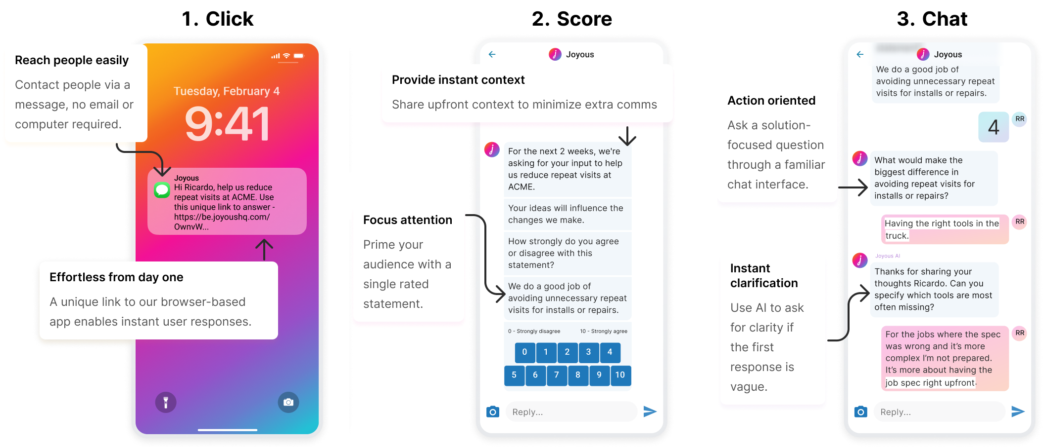

2. Joyous email example
You can use this email as an example in your communications to show team members what to expect when they receive their Joyous questions via email. This will help prevent team members from mistaking the email for spam. Clicking a score will take the audience member straight to their conversations in Joyous, without the need to log in.
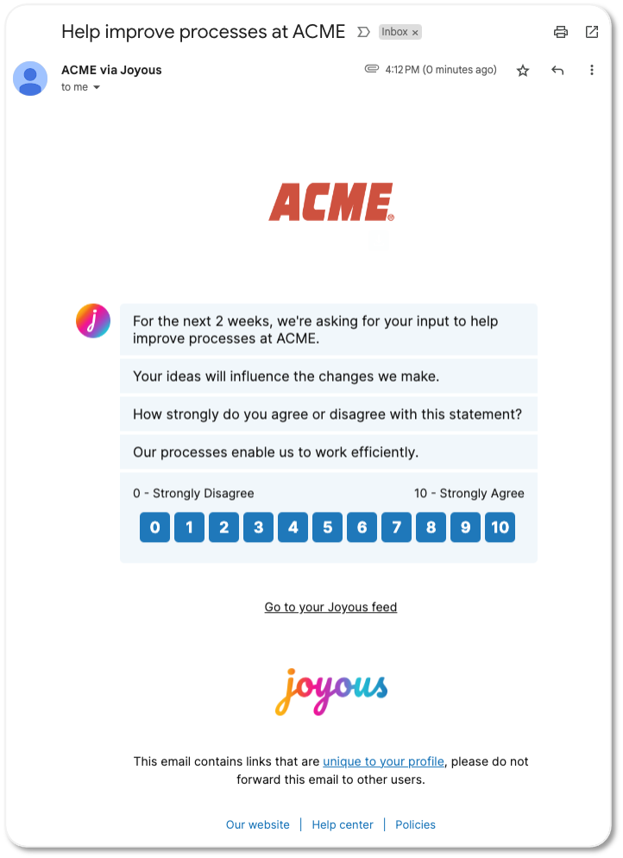
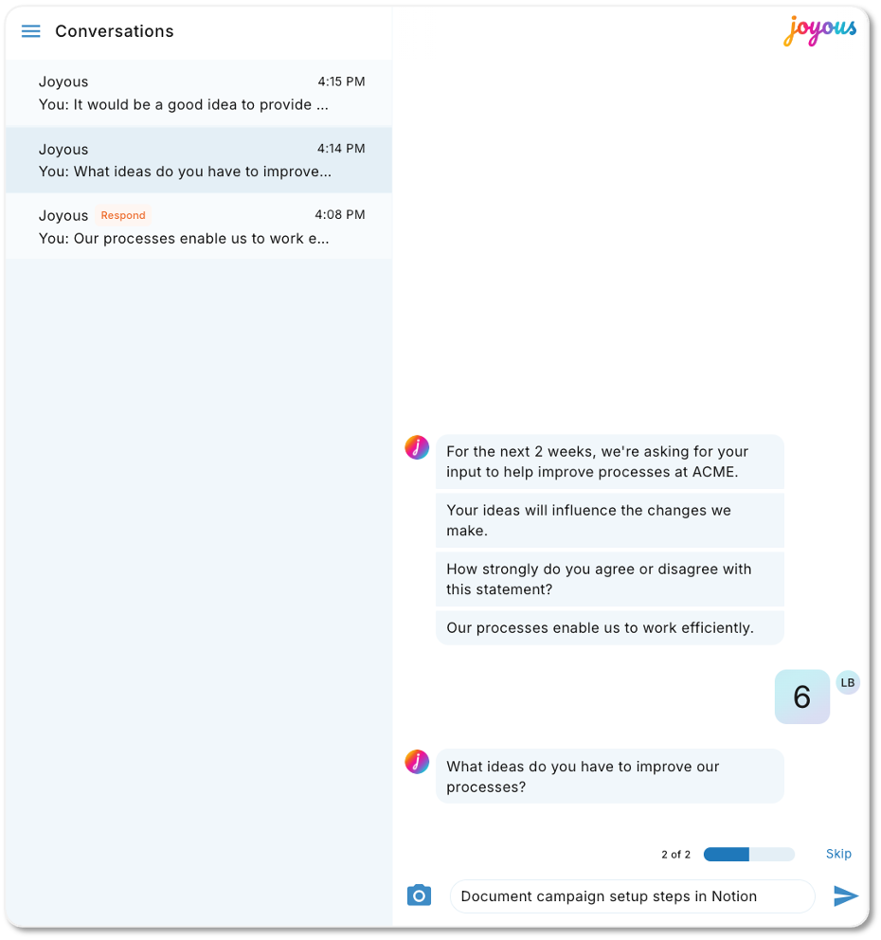

3. Joyous chat apps example
You can use this chat apps example in your communications to show team members what to expect when they receive their Joyous questions via a chat app (e.g. MS Teams, Meta Workplace, Slack, Google Chat). This will help prevent team members from mistaking the message for spam. Clicking the unique link in the Chat app will take audience members straight to their conversations in Joyous, without the need to log in.
